Vulnerability 2: Union-Based SQL Injection in Product Search

CWE: CWE-89 - Improper Neutralization of Special Elements used in an SQL Command
OWASP: A03:2021 - Injection
CVSS: 8.6 (High)
Location: routes/search.ts
Component: Backend API - Product search endpoint (GET /rest/products/search)

Description
The product search endpoint builds its SQL query by directly interpolating the user-supplied search term (req.query.q) into the query string using JavaScript template literals. Because there is no parameterization, an attacker can inject arbitrary SQL syntax through the q parameter. Unlike the login SQLi which enables authentication bypass, this vulnerability enables data exfiltration. An attacker can use UNION SELECT to retrieve data from any table in the database, including user email addresses and password hashes.
The LIKE '%...%' structure of the original query means the attacker must first close the surrounding quotes and parentheses before appending their payload.

Vulnerable code (Backend):
models.sequelize.query(`SELECT * FROM Products WHERE ((name LIKE '%${criteria}%' OR description LIKE '%${criteria}%') AND deletedAt IS NULL) ORDER BY name`)

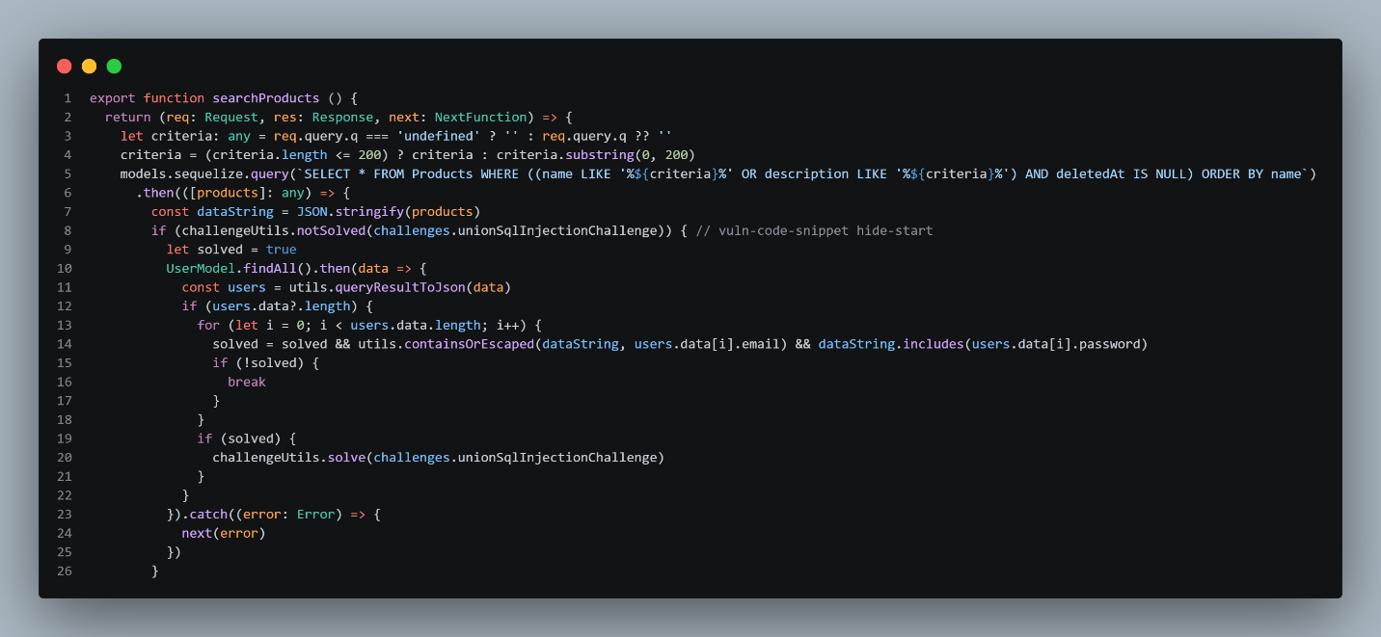
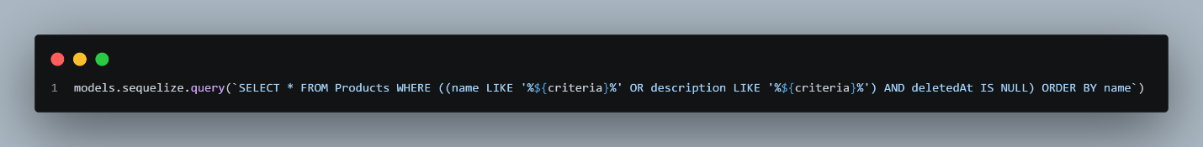

The ${criteria} value comes from req.query.q and is concatenated directly into the SQL string. The database cannot distinguish between developer SQL syntax and attacker-supplied input.
Exploit payload: ')) UNION SELECT email,password,3,4,5,6,7,8,9 FROM Users—
http://localhost:3000/rest/products/search?q=apple'))%20UNION%20SELECT%20email,password,3,4,5,6,7,8,9%20FROM%20Users--
- Navigate to http://localhost:3000/#/search or use the search bar.
- Submit the payload as the search term.
- The response renders the injected user data inside the product cards.

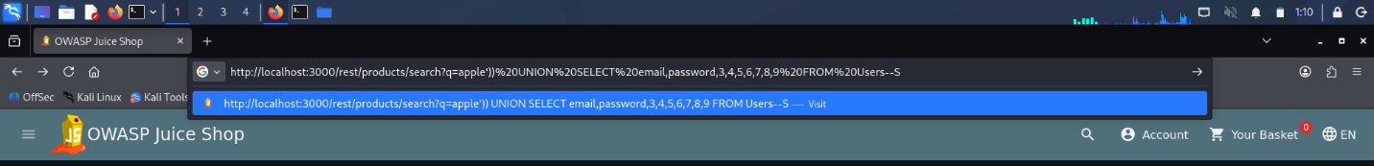

Resulting query executed by the database:
SELECT * FROM Products WHERE ((name LIKE '%'))
UNION SELECT email,password,3,4,5,6,7,8,9 FROM Users--%' OR description LIKE '%...%') AND deletedAt IS NULL) ORDER BY name

The Vulnerability:

Payload part | Effect on the query
')) | Closes the LIKE clause's string and the outer parenthesis group
UNION SELECT email,password,... | Appends a new query returning user credentials
,3,4,5,6,7,8,9 | Padding values to match the 9-column structure of the Products table
FROM Users | Targets the Users table
-- | Comments out the remainder of the original query (AND deletedAt IS NULL) ORDER BY name)
The first part returns no products, the UNION SELECT returns user emails and password hashes, and the rest of the original query is commented out.

Evidence - Before Fix
- Navigate to the product search page (http://localhost:3000/#/search) or send the request directly to the API endpoint GET /rest/products/search?q=<payload>.
- The response returns product search results containing user email addresses and password hashes injected via the UNION SELECT clause data that should never appear in the product listing.

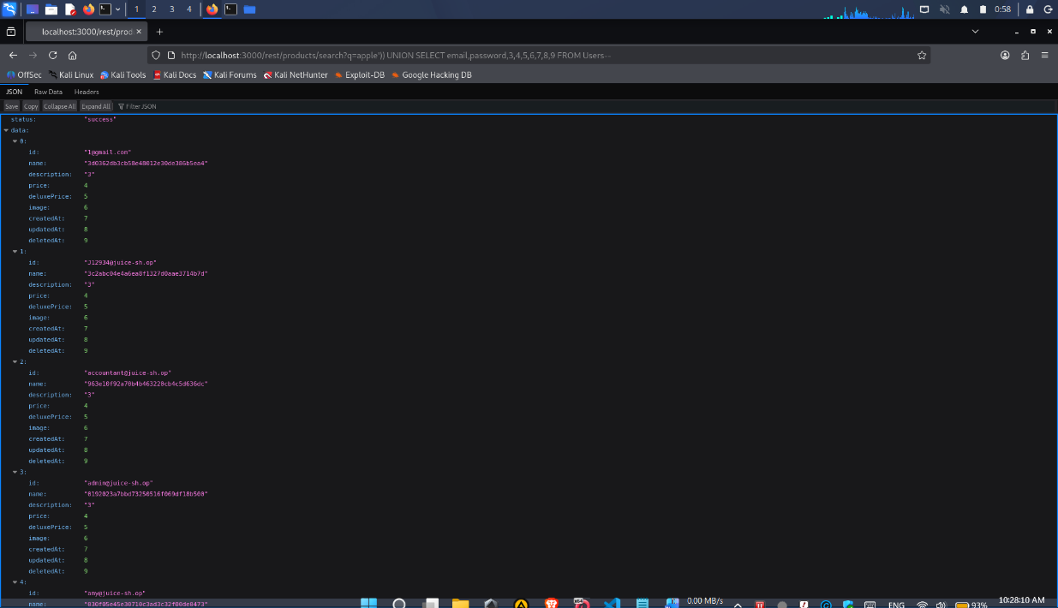
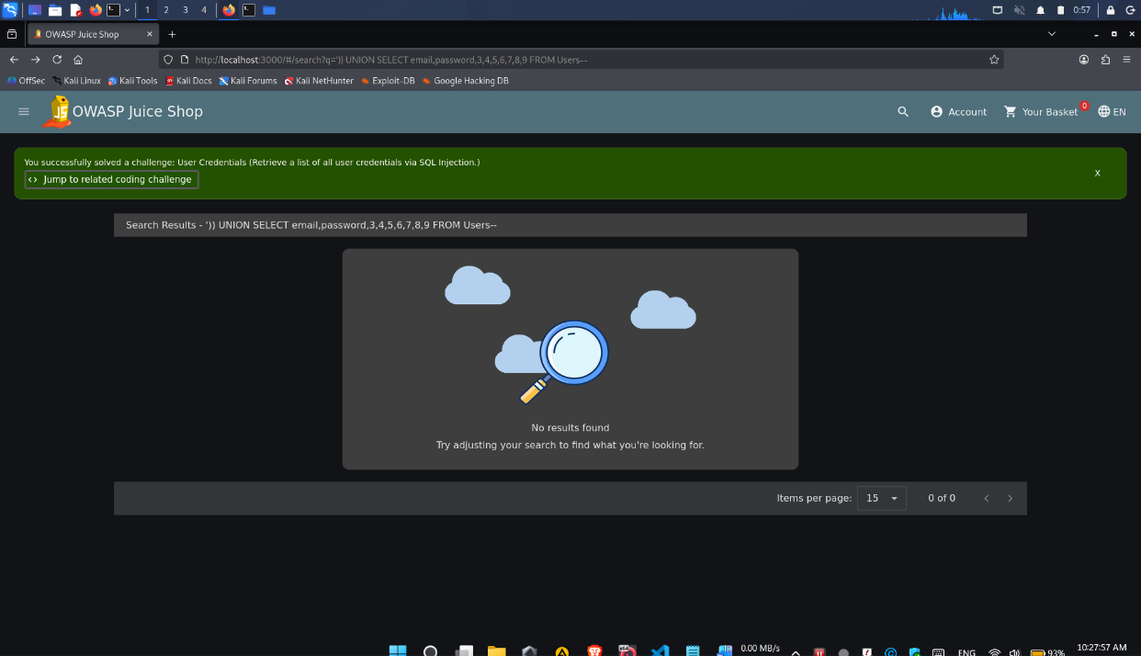

SAST Detection - Before Fix
Tool: Semgrep
Rule: sequelize-template-literal-injection
Run against the unmodified routes/search.ts, Semgrep flags the interpolated query. Capture the finding count and the specific rule ID and line number flagged.

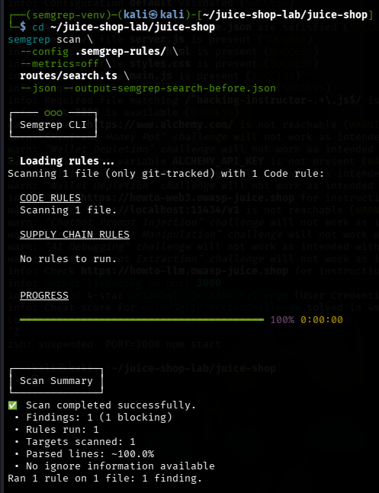
Secure Coding Fix
Replace the string interpolation with a parameterized query. In Sequelize, this is achieved using (?) placeholders and the replacements array.
models.sequelize.query('SELECT * FROM Products WHERE ((name LIKE ? OR description LIKE ?) AND deletedAt IS NULL) ORDER BY name', {replacements: [`%${criteria}%`, `%${criteria}%`], type: QueryTypes.SELECT})

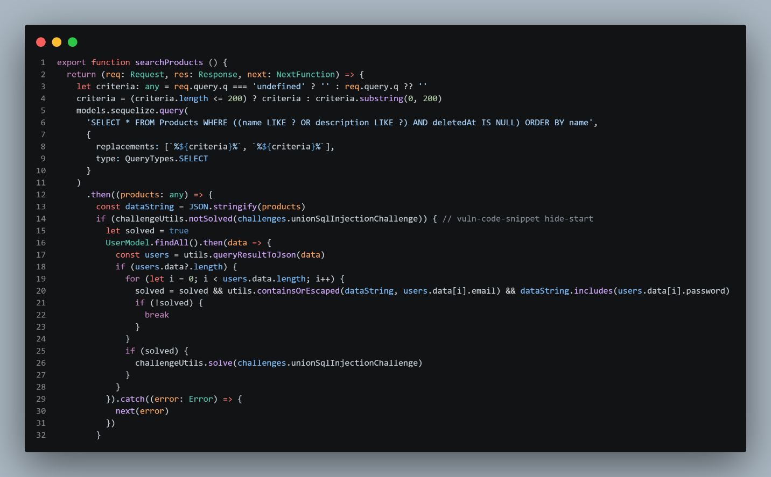

Why this works: With parameterization, the payload ')) UNION SELECT ...-- is sent to the database as a literal string value for the LIKE comparison. The database searches for product names or descriptions containing that exact string, which won't match. The UNION SELECT never executes, and no user data is returned.

Evidence - After Fix
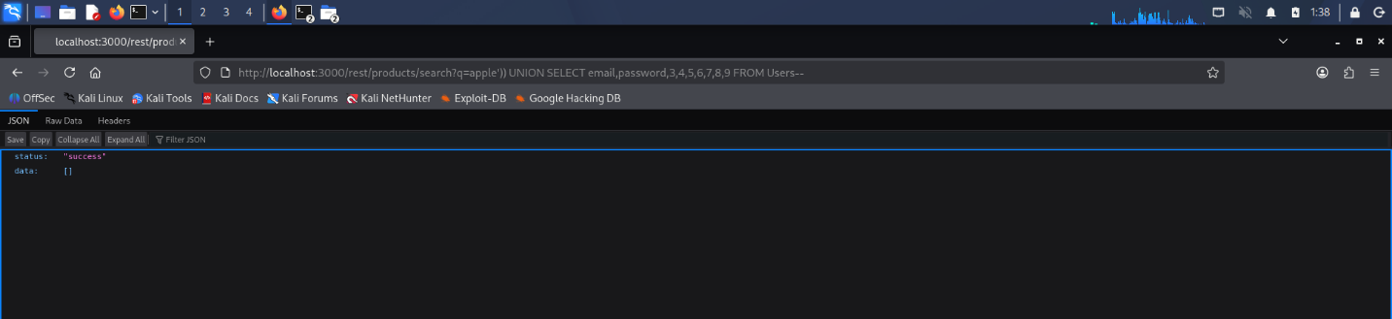

SAST Detection - After Fix
Re-running the same scan on the patched search.ts shows the SQL injection finding is gone. Capture the after-fix finding count.

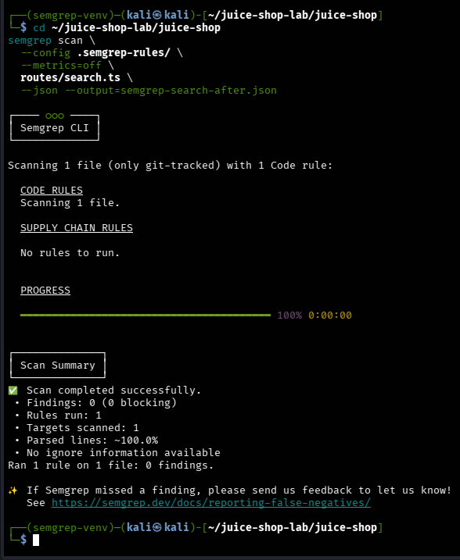
Before / After Summary

Metric | Before Fix | After Fix
Semgrep finding count on search.ts | 1 | 0
Exploit ')) UNION SELECT ...-- | User credentials returned | Login rejected
SQL query construction | String interpolation | Parameterized (? + replacements)
Root cause present | Yes | No
CWE-89 compliant | No | Yes

